**How ArrayList Works Internally in Java**

**ArrayList is a Resizable-array implementation** of the List interface i.e. ArrayList grows dynamically as the elements are added to it.

If the size of the current elements (including the new element to be added to the Array List) is greater than the maximum size of the array then increases the size of array. But the size of the array cannot be increased dynamically. So, what happens internally is, a new Array is created and the old array is copied into the new array

Let’s see how Array List is internally implemented; what is the backing data structure for an Array List, how it grows dynamically.

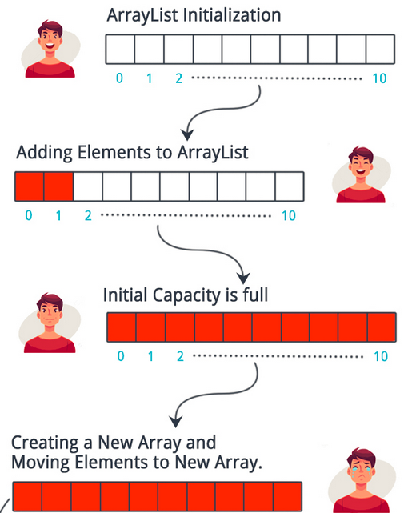

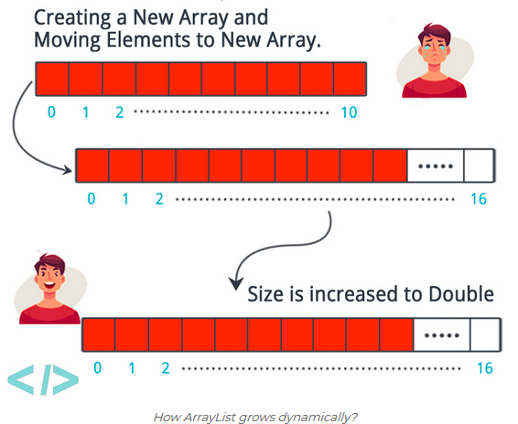

**Where does ArrayList store elements**

Basic data structure used by ArrayList to store objects is an [array](http://netjs.blogspot.com/2017/02/array-in-java.html) of [Object class](http://netjs.blogspot.com/2017/06/object-class-in-java.html), which is defined as follows –

Internally an ArrayList uses an Object [] Array. All the addition, removal and traversal happens on this array.

**In Java 7 or previous**

private transient Object [] elementData;

**In Java 8 or later**

transient Object [] elementData; // non-private to simplify nested class access

As observed, in Java 8 private keyword is removed to provide access to nested class i.e. Itr, ListItr, SubList

ArrayList provides its own version of **readObject** and **writeObject** methods so no problem in serializing an ArrayList and that is the reason, I think, of making this Object array as transient.

**What happens when ArrayList is created**

ArrayList class in Java provides **3 constructors** to create an ArrayList.

* **public ArrayList (int initialCapacity)** - When this [constructor](http://netjs.blogspot.com/2015/04/constructor-in-java.html) is used we can provide some initial capacity rather than depending on the default capacity as defined in the ArrayList class.  
  **As example -**

List<String> myList = new ArrayList<String> (7);

Code in the ArrayList class is as -

public ArrayList(int initialCapacity) {

if (initialCapacity > 0) {

this.elementData = new Object[initialCapacity];

} else if (initialCapacity == 0) {

this.elementData = EMPTY_ELEMENTDATA;

} else {

throw new IllegalArgumentException("Illegal Capacity: "+ initialCapacity);

}

}

Where **EMPTY_ELEMENTDATA** is defined as -

private static final Object [] EMPTY_ELEMENTDATA = {};

It is easy to see that, if provided capacity is greater than zero then the elementData array will be created with that capacity, in case provided capacity is zero then elementData array is initialized with an empty Object array. In that case ArrayList will grow when first element is added.

• public **ArrayList ()** - In case **default constructor** is used i.e. ArrayList is created like - myList = new ArrayList ();

Code in the ArrayList class is as -

public ArrayList () {

this.elementData = DEFAULTCAPACITY_EMPTY_ELEMENTDATA;

}

Where **DEFAULTCAPACITY_EMPTY_ELEMENTDATA** is defined as

/**

* Shared empty array instance used for default sized empty instances. We

* distinguish this from EMPTY_ELEMENTDATA to know how much to inflate when

* first element is added.

*/

private static final Object [] DEFAULTCAPACITY_EMPTY_ELEMENTDATA = {};

So, you can see initially it will be initialized with an empty array, it will grow only when first element is added to the list.

• **public ArrayList(Collection<? extends E> c)** - If we want to construct a list containing the elements of the specified collection we can use this [constructor](http://netjs.blogspot.com/2015/04/constructor-chaining-in-java-calling-one-constructor-from-another.html). In this constructor implementation checks for the length of the collection passed as parameter, if length is greater than zero then Arrays.copyOf method is used to copy the collection to the elementData array.

elementData = Arrays.copyOf(elementData, size, Object[].class);

**How does ArrayList grow dynamically**

When we add an element to an ArrayList it first verifies whether it has that much capacity in the array to store new element or not, in case there is not then the new capacity is calculated which is 50% more than the old capacity and the array is increased by that much capacity (Uses Arrays.copyOf which returns the original array increased to the new length).

Code in the Java ArrayList implementation is like this-

public boolean add (E e) {

ensureCapacityInternal(size + 1); // Increments modCount!!

elementData[size++] = e;

return true;

}

private void ensureCapacityInternal(int minCapacity) {

if (elementData == DEFAULTCAPACITY_EMPTY_ELEMENTDATA) {

minCapacity = Math.max(DEFAULT_CAPACITY, minCapacity);

}

ensureExplicitCapacity(minCapacity);

}

Where DEFAULT_CAPACITY is defined as -

private static final int DEFAULT_CAPACITY = 10;

private void ensureExplicitCapacity(int minCapacity) {

modCount++;

// overflow-conscious code

if (minCapacity - elementData.length > 0)

grow(minCapacity);

}

You can see here it is determined if there is a need to increase the size of the array, if yes then grow method is called.

private void grow(int minCapacity) {

// overflow-conscious code

int oldCapacity = elementData.length;

int newCapacity = oldCapacity + (oldCapacity >> 1);

if (newCapacity - minCapacity < 0)

newCapacity = minCapacity;

if (newCapacity - MAX_ARRAY_SIZE > 0)

newCapacity = hugeCapacity(minCapacity);

// minCapacity is usually close to size, so this is a win:

elementData = Arrays.copyOf(elementData, newCapacity);

}

Note that till **Java 6** the new capacity calculation used to be like this -

int newCapacity = (oldCapacity * 3)/2 + 1;

Which is changed in **Java 7** to use right shift operator. With right shift operator also, it will grow by 50% of old capacity.  
Let's see it with the help of a small program

public class Test {

public static void main (String args[]) {

int a = 10;

System.out.println(a>>1);

}

}

**Output**

5

If the default capacity was 10 then

int newCapacity = oldCapacity + (oldCapacity >> 1); will return 15.

**What happens when an element is removed from ArrayList**

When elements are removed from an ArrayList in Java using either **remove(int i)** (i.e using index) or **remove(Object o)**, gap created by the removal of an element has to be filled in the underlying array. That is done by Shifting any subsequent elements to the left (subtracts one from their indices). **System.arrayCopy** method is used for that.

System.arraycopy(elementData, index+1, elementData, index, numMoved);

Here index+1 is the source position and index is the destination position. Since element at the position index is removed so elements starting from index+1 are copied to destination starting from index.

**Points to note**

1. ArrayList in Java is a **Resizable-array implementation** of the List interface.
2. Internally ArrayList class uses an **array of Object** class to store its elements.
3. When initializing an ArrayList you can provide initial capacity then the array would be of the size provided as initial capacity.
4. If initial capacity is not specified then default capacity is used to create an array. Default capacity is 10.
5. When an element is added to an ArrayList it first verifies whether it can accommodate the new element or it needs to grow, in case capacity must be increased then the new capacity is calculated which is 50% more than the old capacity and the array is increased by that much capacity.
6. When elements are removed from an ArrayList space created by the removal of an element must be filled in the underlying array. That is done by Shifting any subsequent elements to the left.

**How HashMap works internally**



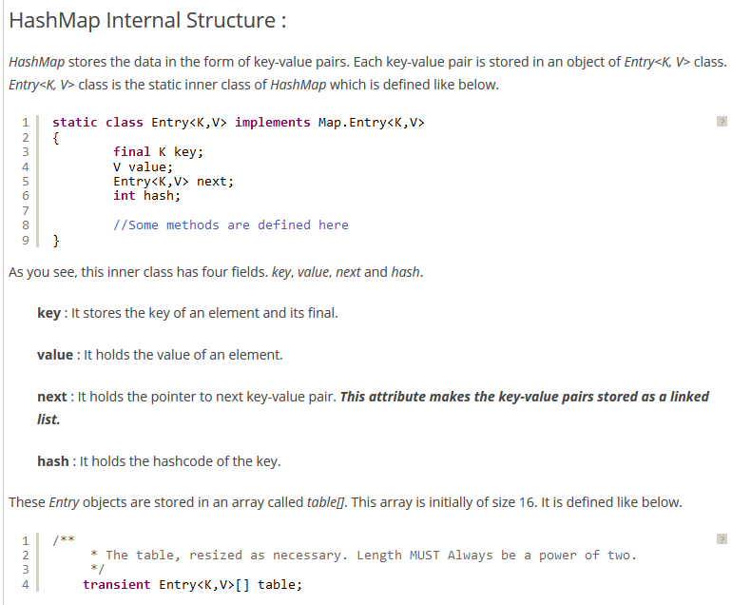



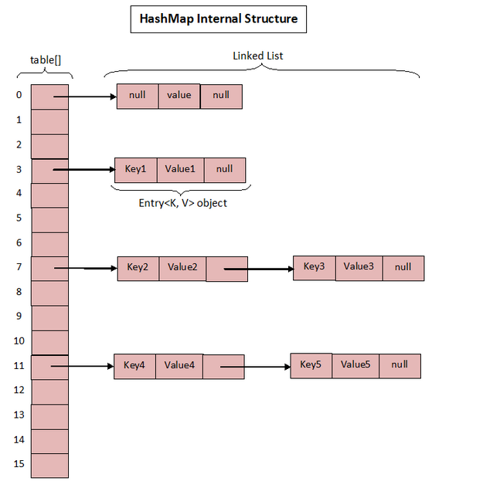

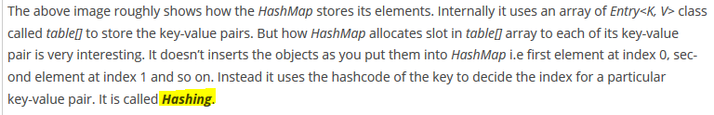

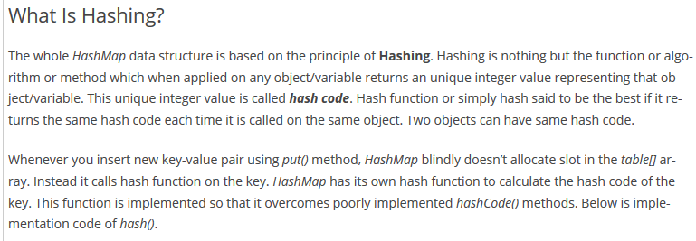

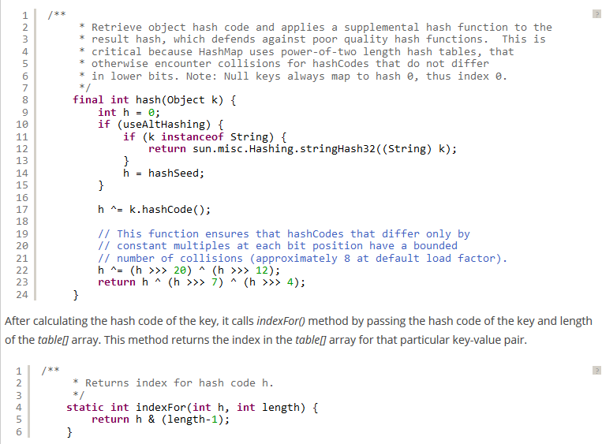

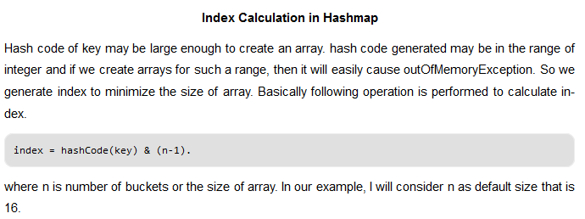

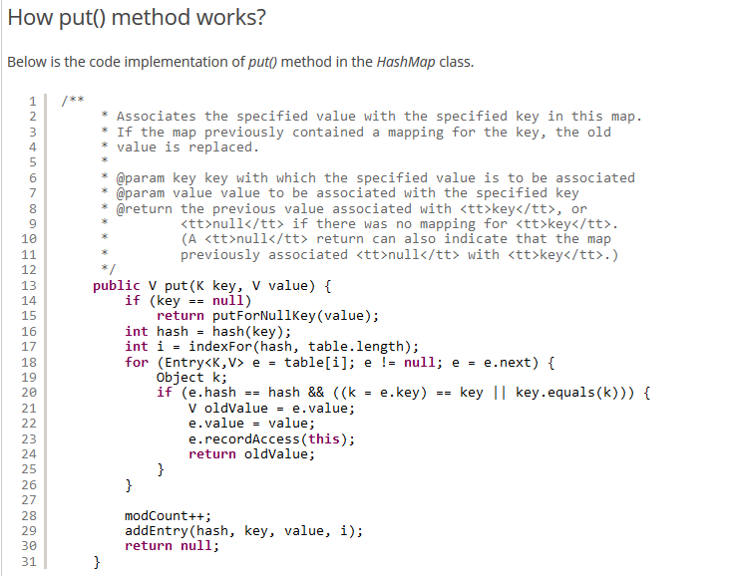

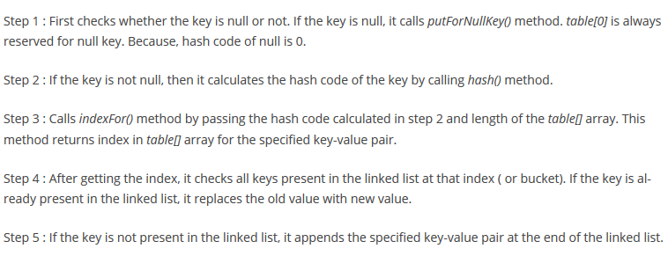

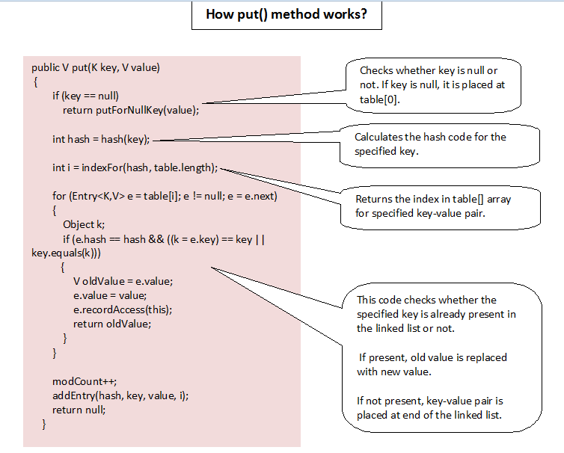

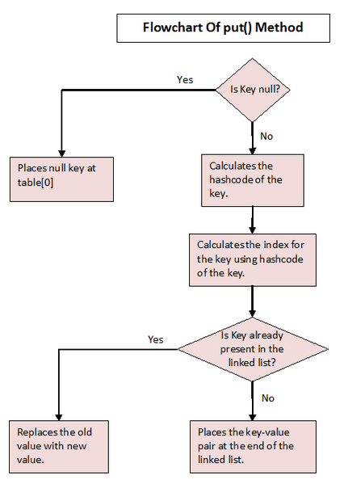

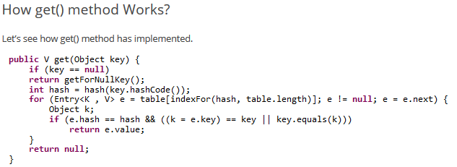

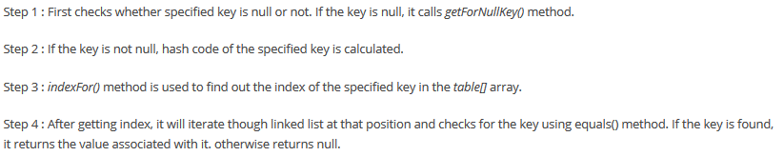



**Solution to search an element:**





**Hashing:**





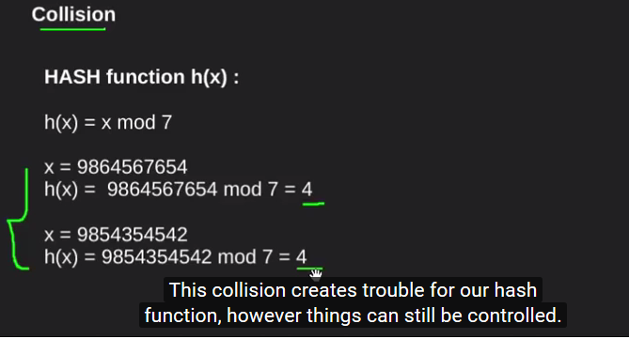



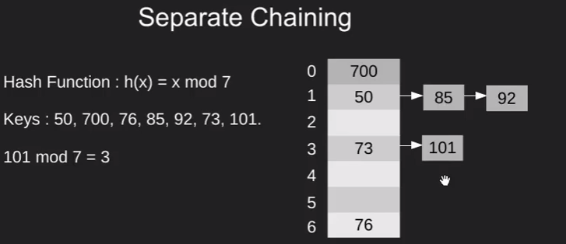





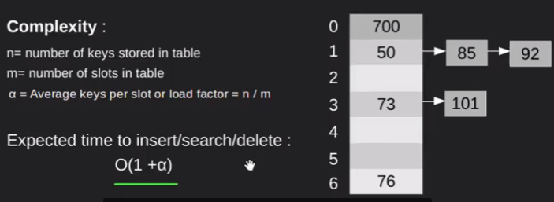

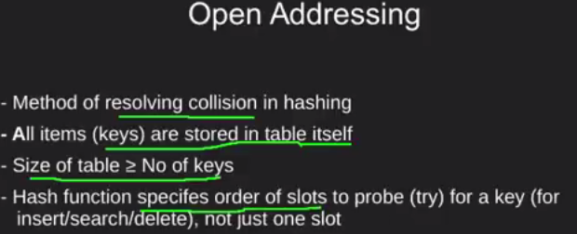



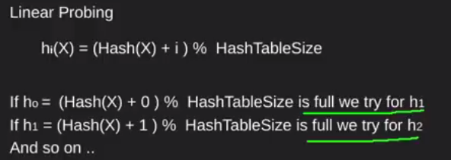

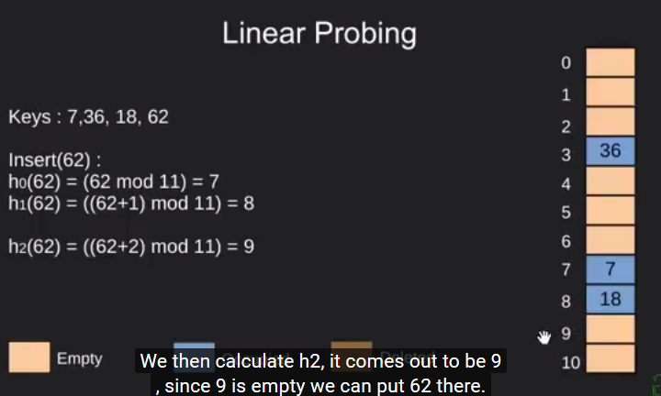

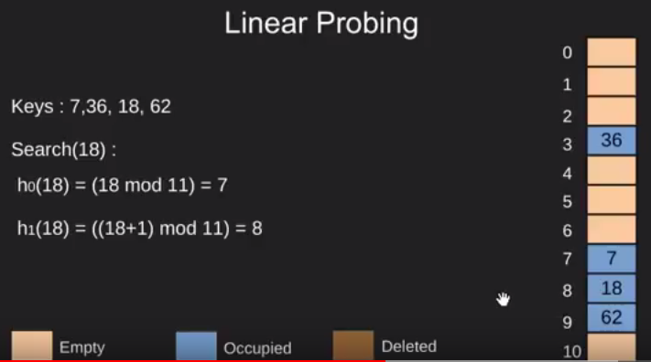

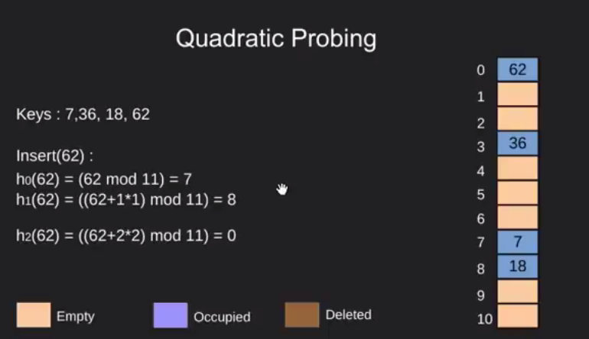





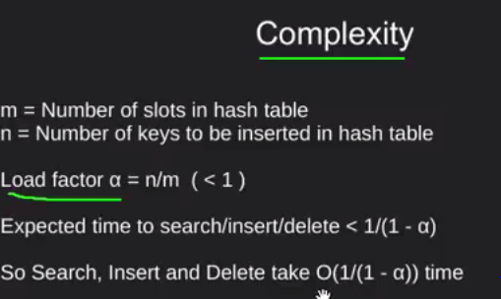





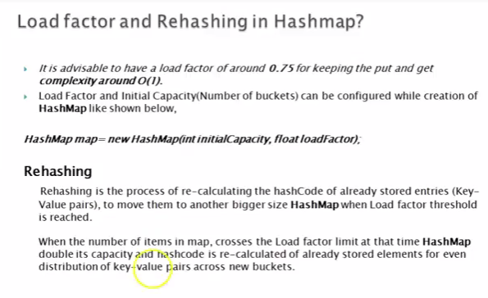



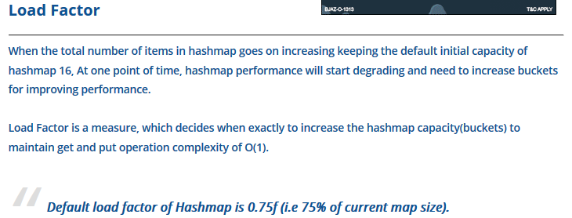

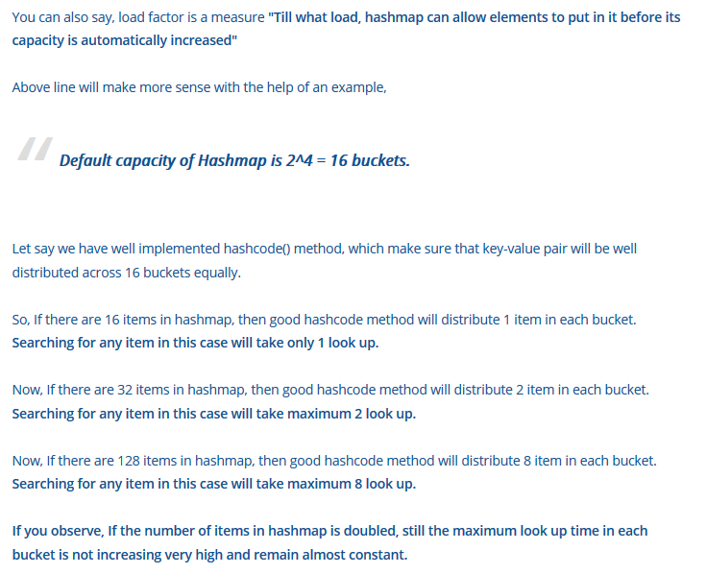



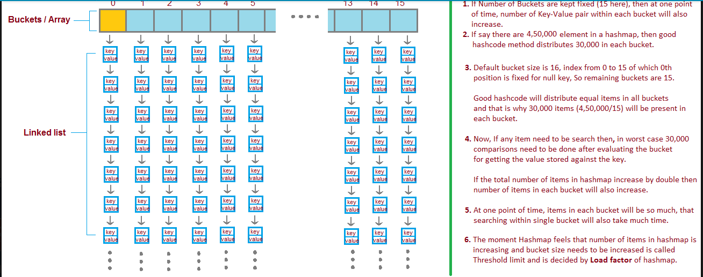

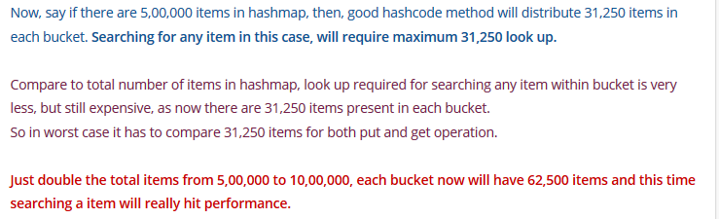

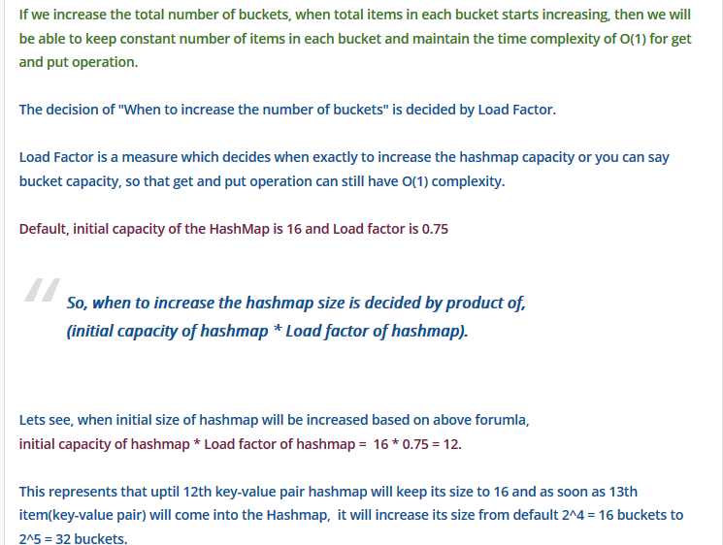

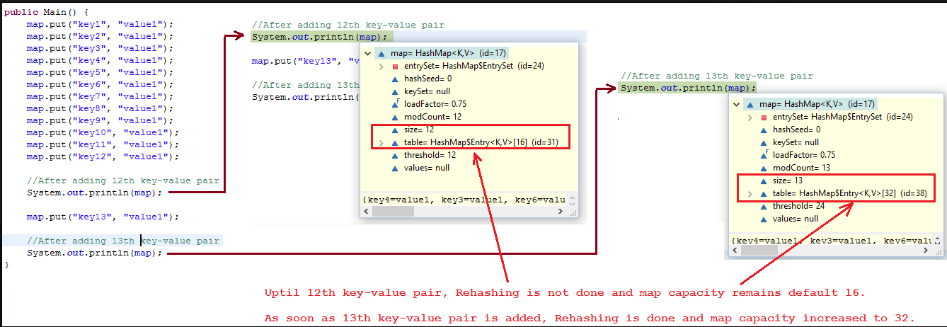

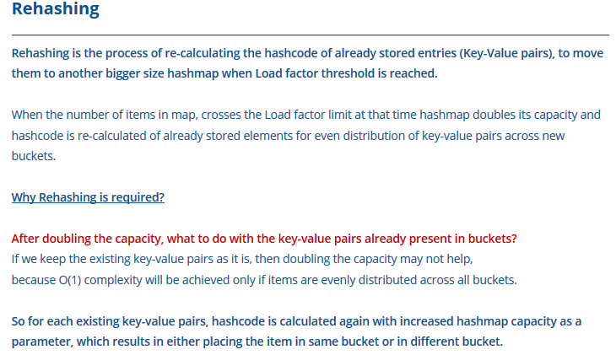

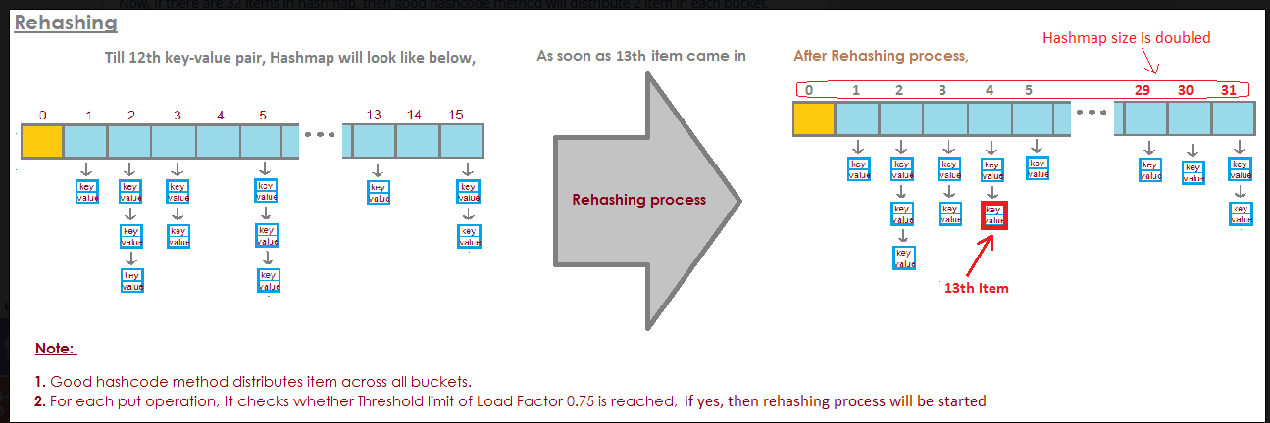

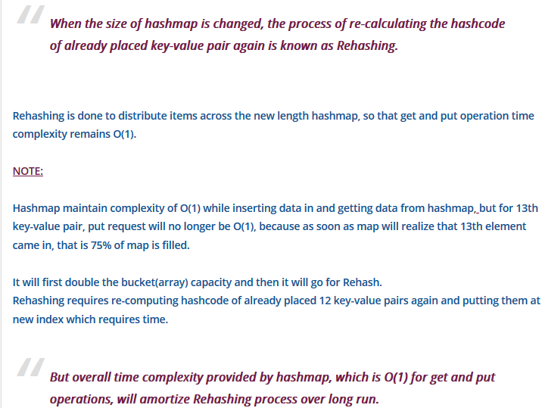

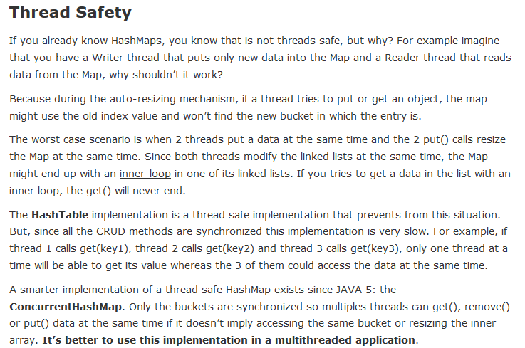

**How Tree Map works:**

